LEBANON WINS 2020 UN GLOBAL CLIMATE ACTION AWARD!
Beirut, 18 November, 2021
RISE2030, a Lebanese women-led initiative, announced that it was named winner of the 2020 UN global climate action award – women for results category. The highly coveted award is a first for Lebanon. The Rise2030 team was invited to participate in COP26 in November 2021 as award recipients and speakers. The global event, which was supposed to take place in 2020, was delayed due to the COVID-19 pandemic.
“We are deeply honored to receive this award and to represent Lebanon in these times of adversity.” Said Ryme Assaad, Executive Director of RISE2030. “Once again, women are proving to be leaders of change in designing, developing and building climate-friendly solutions that can and will help Lebanon during its hardest energy, economy and health crises.”
The UN Global Climate Action Awards are spearheaded by the UN Climate Change Convention, Momentum for Change initiative. The Rise2030 initiative, along with the other winning projects are recognized as innovative solutions that not only address climate change, but also help advance sustainable development. The initiatives, celebrated at COP26, represent some of the most practical, scalable and replicable examples of climate-conscious solutions that can enable communities to achieve sustainable development goals such as: innovation, gender equality and economic opportunity.
“The last eight months have been a nightmare for many throughout the world,” said UN Climate Change Executive Secretary Patricia Espinosa. “COVID-19 has altered lives, economies and the nature of business on every continent—from the largest cities to the smallest villages. It is the most urgent threat facing humanity today, but we cannot forget that climate change is the biggest threat facing humanity over the long term.”
The RISE2030 team attended COP26 in Glasgow, in November, to participate in the climate change summit, join the climate action conversation and take part in the global negotiations.
“We need to support Lebanon and help create job opportunities for underserved youth and women in the renewable energy sectors, in order to tackle the rising economic, social and environmental challenges that our country is facing.” said Amani Dibo, Community Health Director and PR Director at Sustain The World.
About Rise2030
Rise2030, an initiative managed by Sustain The World and Sustainable Empowerment for Youth International, is a community-led initiative that focuses on empowering women and youth, aiming at capacity building and improving living conditions through access to education and employment. RISE2030 launched the first all-women solar team in Lebanon to challenge the gender stereotypes in the male-dominated construction sector.

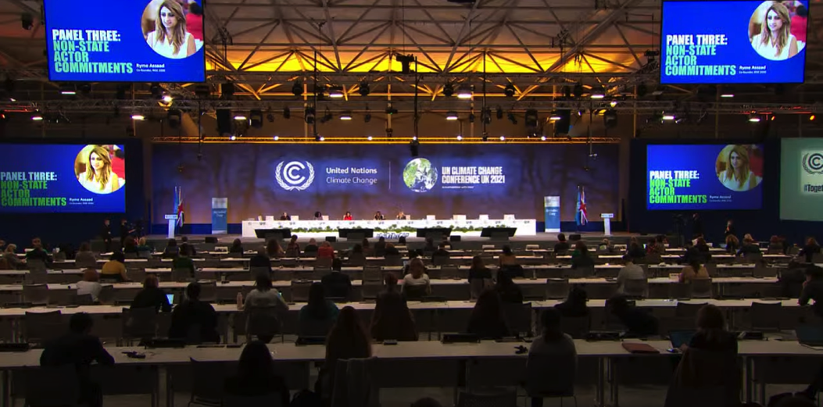
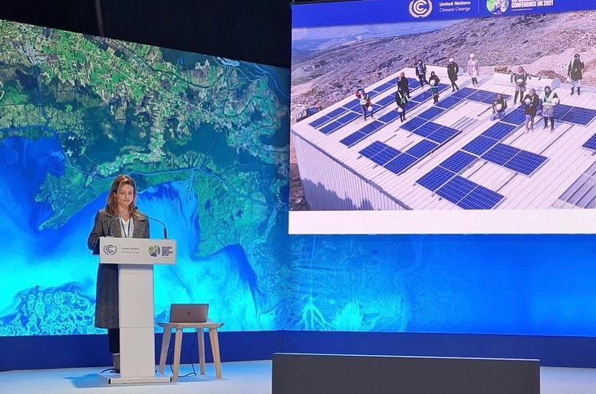
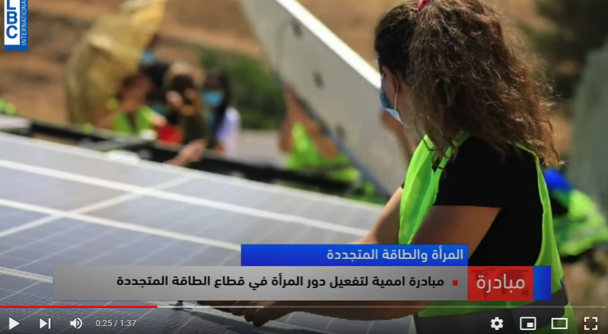
https://www.youtube.com/watch?v=mD4l_awZzhE
Media Contact
Amani Dibo - Public Relations
amani@sustaintheworld.org
www.sustaintheworld.org

